SOFT8026 - Data-driven Microservices
Assignment 2 Form

Instructions
Please complete the following form and include in the zip file you submit. Include screenshots / images in the appendices below the form.

Move to Kubernetes
Describe the progress you made moving your app to Kubernetes | The whole project has been moved to Kubernetes. The images are hosted on dockerhub.  There are limits set on resources (which makes the resource usage more predictable), an update strategy is in place, and the ratios of different microservices are configured in an attempt to utilise everything as efficiently as possible.
Describe what additional functionality you added, e.g. 2nd data source | The reddit posts are served and analysed. Rather than adding extra functionality to the Tweet server and client, I decided to create separate microservices for the Reddit posts. This way, they are smaller, meaning that less resources are being wasted (the container does not have 2 databases loaded) and allow for more flexibility (eg: 3 tweet servers, 1 reddit server, if someone wishes to set it up that way).  From the data that is streamed, there is once again an all-time total of word and vowels kept, with an average number of vowels per word. There is also a 3-minute sentiment, which keeps track of how many tweets are positive/negative and how many of the reddit posts are over/under 18. We keep track of most words in a tweet/reddit post.  Due to the quickly growing size of the website (especially with all of the analysis clients in the cluster), it was decided to display the most recent tweets and posts (those that arrived within last 10 seconds) rather than listing all of the tweets that have been streamed in the past.
Describe your scaling and update strategy (as implemented in your Kubernetes deployments) – e.g. include why you chose to scale in the ratio among microservices that you did | The RollingUpdate strategy is used, with the maxUnavailable and maxSurge kept at 10%. This way, when at update is made, everything will gradually be swapped out, and there won’t be any major unexpected drops in performance due to the lower maxUnavilable being set to a rather low number. Not only does it prevent sudden drops in performance, it also removes the requirement of having a lot of spare resources laying around to accommodate higher surges.  We make sure that each container is ready for at least 10 seconds before proceeding any further.  The only exception to this update strategy is the redis server, of which there is just 1 instance (due to data consistency issue that arose when having multiple pods and no master to sync data properly between them).  Each of the containers have “limits” and “requests” set on the resources. These limits were decided after running the cluster for a while and seeing what resources were required. This helped to get an understating on how many replicas I can run on my environment, and in what ratios, as the numbers were very predictable.  There is only 1 redis pod, which has much higher specs compared to the other deployments, due to having to handle a bigger load, while trying to avoid that data inconsistency. There are 2 replicas of each of the servers, primarily for redundancy. There are 4 replicas of each of the analysis clients, as they are light weight (there could defiantly be twice or thrice as many clients, before the servers would feel any toll on them, but my machine would start to get sluggish when too many were used, with the IDE running simultaneously). There are 2 website replicas.  Using multiple replicas provides redundancy in case something temporarily goes down.  By analysing the usage between the different microservices, it appears that I would have been able to easily scale to somewhere around 6 to 8 analysis clients for each server to maximise its usage, but the resources on my machine were the limiting factor, hence why I left it at a lower ratio.
Testing
Briefly describe the test you created and what type of test it is? | A non-functional test was carried out. The test focused primarily on the response time of the service, based on the number of users that are interacting with it.  The test starts with 0 concurrent users and adds 5 additional concurrent users at every level. There are 10 levels, and each level lasts 20 seconds.  The result of this test is the response time of the website where there are 5, 10, 15, 20, etc users.
Why did you choose that test? | For a business, it is important that they can handle a desired number of users and are prepared for future growth.  A test like this allows them to gain insight into how the system behaves under load at different stages, and prepare for future number of users. This test can of course be tweaked later in the future to do bigger increments, or more levels.
How did or how would you automate the test? | I managed to schedule a cron job to do the test automatically at certain times.  This cron job could also be deployed to a container that runs indefinitely and carries out the test at specific times.  If using CI/CD, a hook from the code repository could be setup to an automation server, such as Jenkins, that deploys a container that runs the test and uploads the result before terminating.  Alternatively, there is also a plugin for Jenkins, that can be setup to execute a simulation, generate a report and archive it. The setup is like any other job on Jenkins.
Monitoring
Briefly describe the monitor you created and what type of monitor it is? | The Kubernetes dashboard was the best form of monitoring that worked. It monitors the CPU and memory usage of the pods over a period of time. It also displays additional information such as the status of the pods, and how many restarts happened, and the total resources used in the cluster.
Why did you choose that monitor? | In order to know how the system is behaving, and what it is capable of, it’s important to have an insight. By looking into the performance over time of the pods and deployments, I was able to determine how many resources should be dedicated to each of them, and in what ratios they can be ran. It also helped me to determine that the server is capable of handling many more analysis clients than currently used (with the limitation being my machine).  These insights give opportunities to businesses to scale in a way that reduces costs as much as possible. Without it, they would be left wasting valuable time by guessing settings and waiting to see how the system responds, or inefficiently scaling their services, for example dedicating 2 analysis clients for each server, where in reality, 6 to 8 analysis clients could be present for each server.  I got as far as setting up a Prometheus and Grafana for displaying data and metrics, but it was much more work, and the data I could access was very limited.  I investigated a bit more into the problem. I think the main problem is the authentication issue when trying to access Kubelet/metrics and Kubelet/metrics/cadvisor endpoint. The endpoint constantly complains about requests being unauthorised (error 401).  I came back and tried to set up Prometheus and Grafana a few more times once I had the project finished, but ultimately ended up breaking the cluster a good few things. Every reset of the whole cluster and running of the setup script, would take me around an hour or two with my internet connection.  For what it’s worth, I’ve attached screenshots (appendix E) of what I manged to have up and running with Prometheus and Grafana, but ultimately, the Kubernetes dashboard provided more functionality and was easier to setup.
Serverless Function
What serverless function and functionality did you implement? | The website provides data on the number of words and vowels in a sentence. The serverless function is built to calculate those results. It takes in the string, and the returns the number of words and vowels in a json format.
Where in your application did you or would you slot in this functionality? | This functionality can go into the reddit and tweet analysis clients.  I got as far as calling the function by using the IP address of the cluster. This function did not make its way into the final client images, as the IP address of the serverless function changes with every run.  The way this worked with the hardcoded IP address was by importing the requests library in python, setting the data to the tweet/reddit message and posting it to the serverless function, which returns a json response for parsing.
Any other comments? | All of the images for the containers are available on dockerhub. If you would like to use docker-compose locally for any reason, please put the two extracted datasets (training.1600000.processed.noemoticon.csv and r_dataisbeautiful_posts.csv) into the root of the project folder.  I have also written a script that first sets up the deployments, services and serverless function. Then it sets up the monitoring and gives instructions on how to access it. This can be done by running “./setup.sh”. I recorded a video and fast-forwarded it, as the whole process can take a while. There’s also a “delete-deployments-services-and-functions.sh” script, which deletes the deployments, services and functions (it does not fully clean up the monitoring).  There is also a second video of the testing, which shows the test running and how the resource usage increases for the monitored pods.  Once everything is up and running, the website is available on localhost:30000, and the Kubernetes dashboard on localhost:10443

Appendix A – Screenshot(s) of your application running (e.g. Kubernetes log output, any web pages, etc.)

Figure 1 Updated website with tweets and reddit posts being streamed and analysed

Appendix B – Screenshot(s) of your application being tested
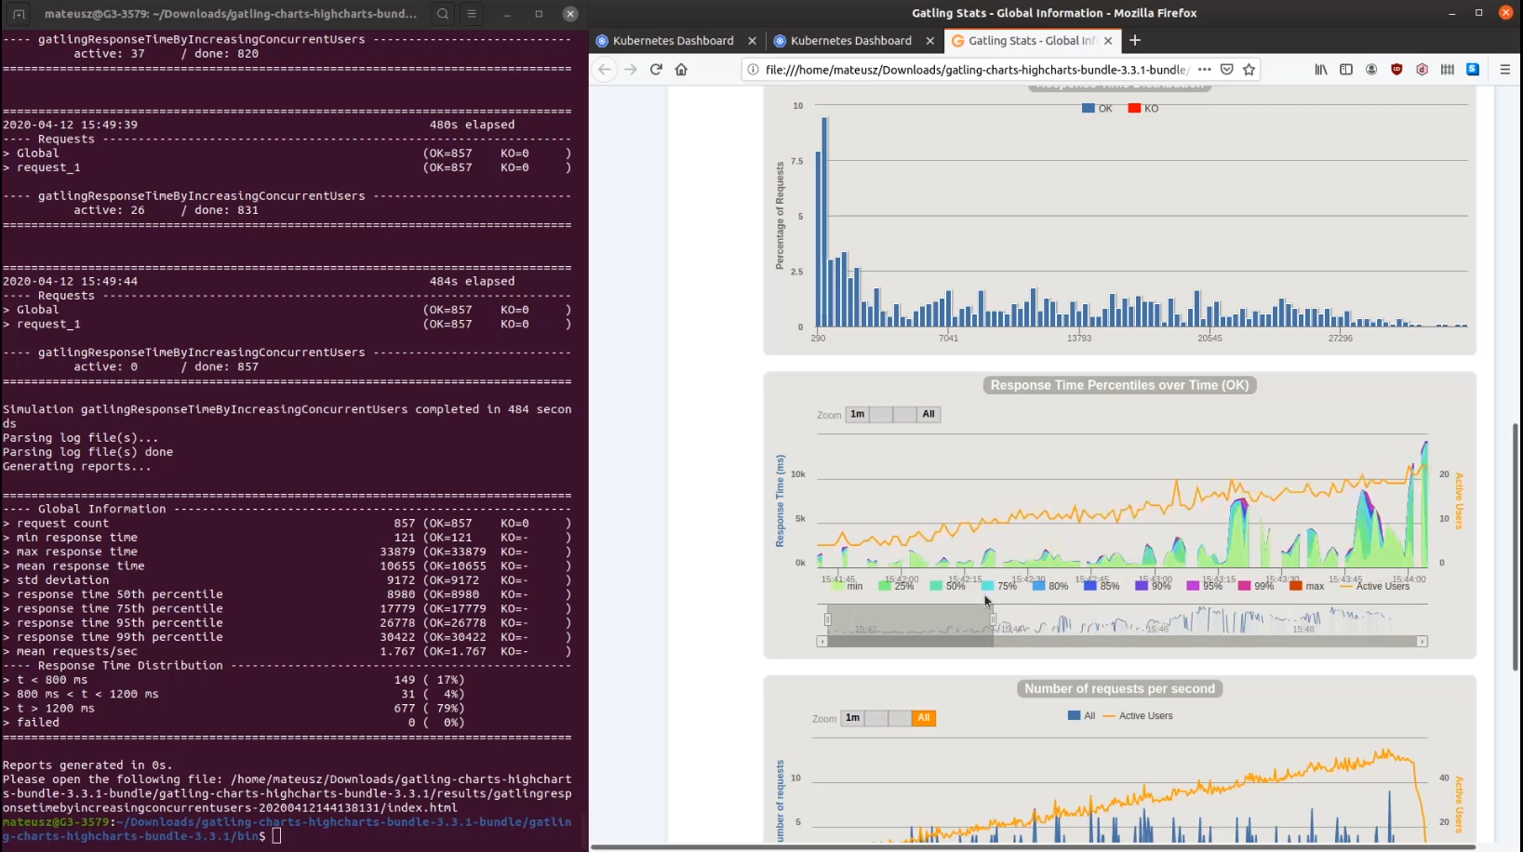
Figure 2 Gatling test with a response time graph based on number of concurrent users

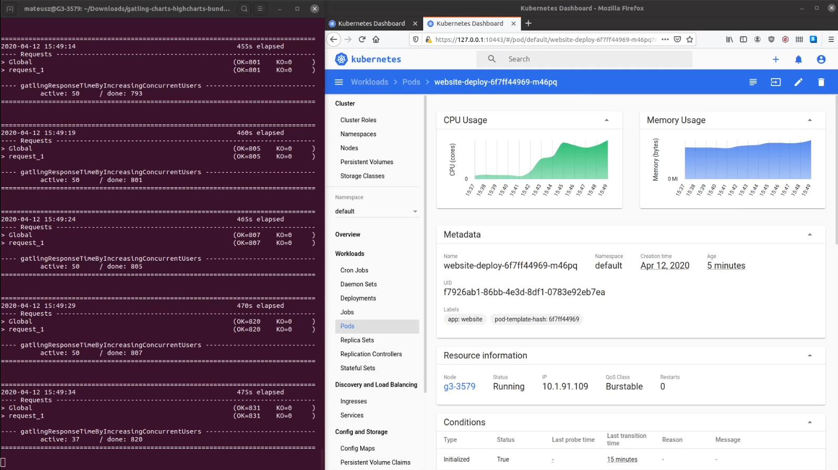
Figure 3 Spike in resource usage as test is performed

Appendix C – Screenshot(s) of your application being monitored
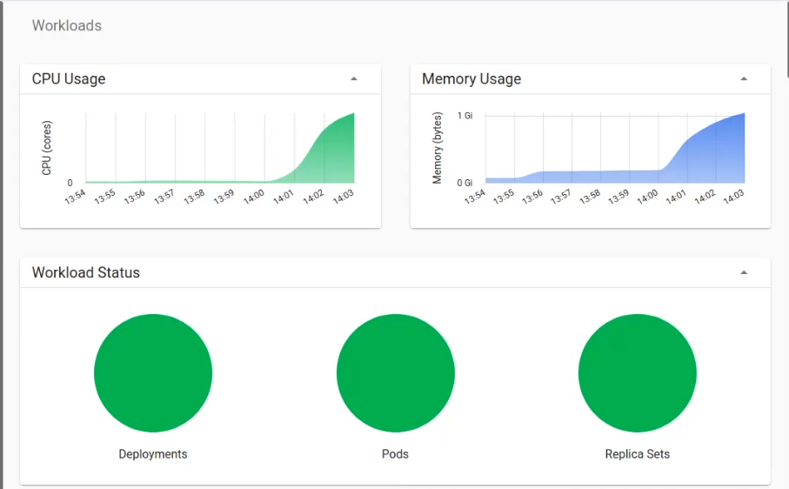
Figure 4 Total workload across all namespaces

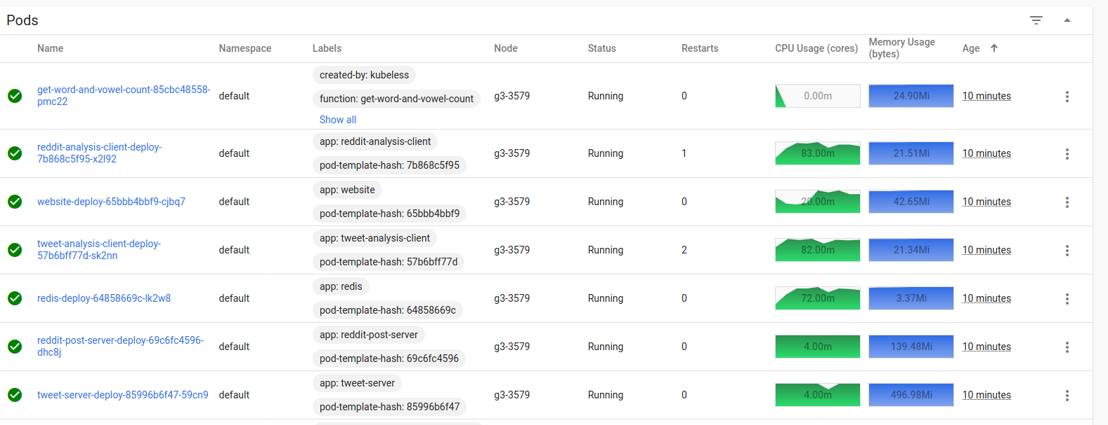
Figure 5 Monitoring on each pod

Appendix D – Screenshot(s) of your serverless function running
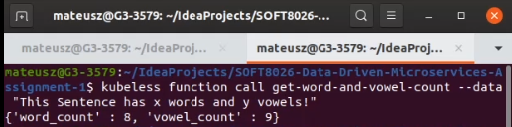
Figure 6 Calling serverless function from the terminal

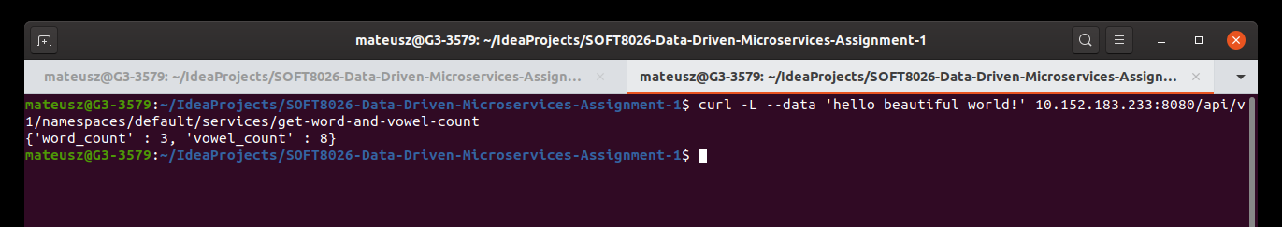
Figure 7 Using Curl and the IP address to call the serverless function


Figure 8 Calling serverless function from python

Appendix E – Screenshot(s) of Prometheus and Grafana monitoring
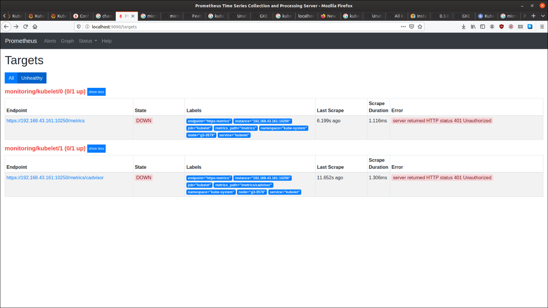
Figure 9 Prometheus failing to authorise with the kubelet endpoint
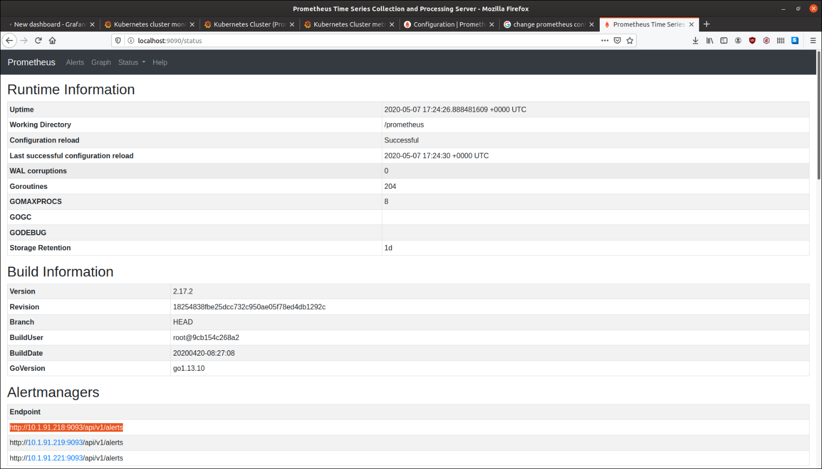
Figure 10 Prometheus appears to be running correctly
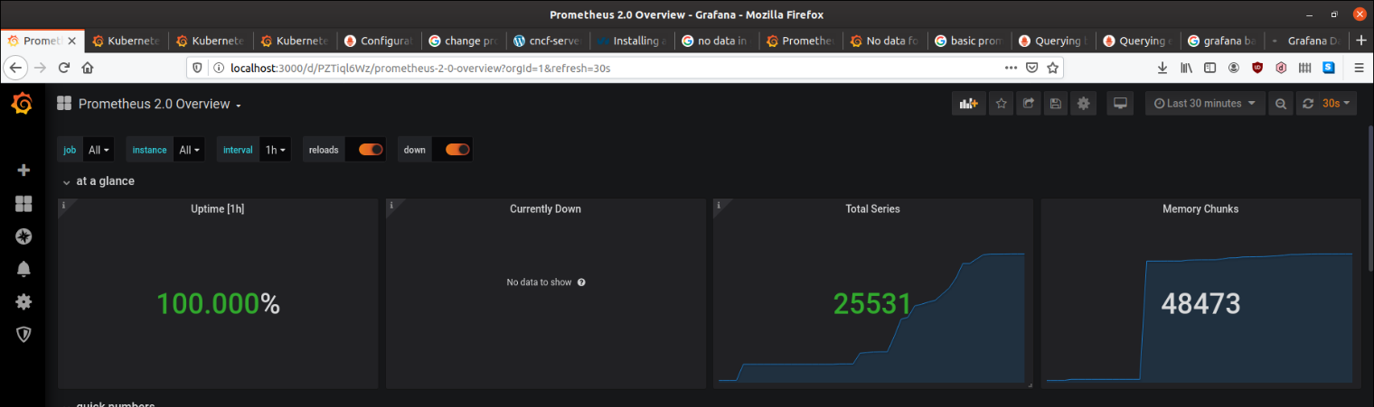
Figure 11 Prometheus microservice overview in Grafana

